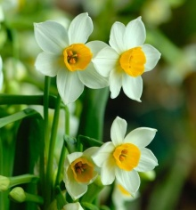



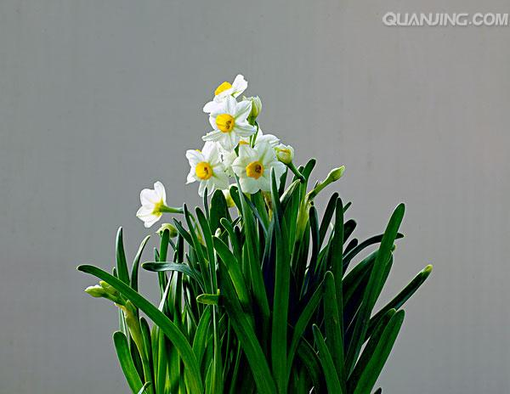

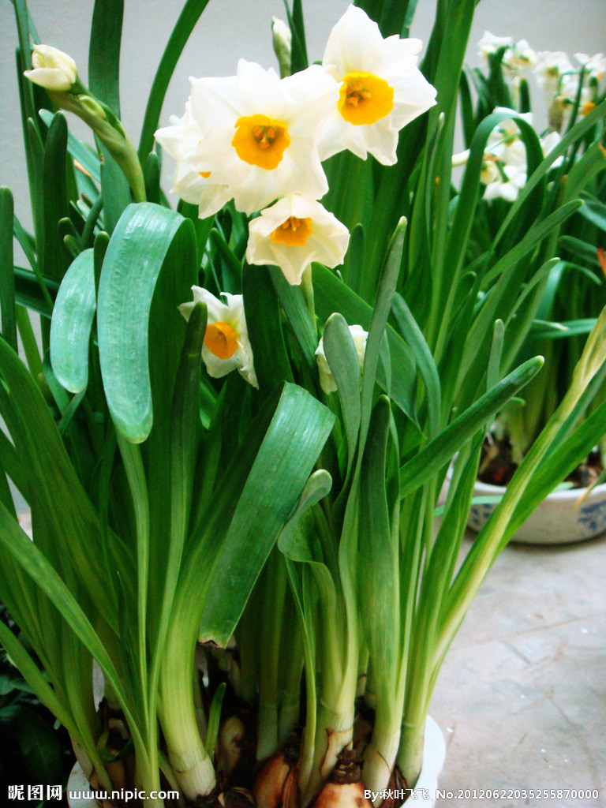

I Wandered Lonely As a Cloud 1804

Wordsworth
I wandered lonely as a cloud
That floats on high o'er vales and hills,
When all at once I saw a crowd,
A host of golden daffodils;
Beside the lake, beneath the trees,
Fluttering and dancing in the breeze.
Continuous as the stars that shine
And twinkle on the milky way,
They stretched in never-ending line
Along the margin of a bay:
Ten thousand saw I at a glance,
Tossing their heads in sprightly dance.
The waves beside them danced; but they
Out-did the sparkling waves in glee:
A poet could not but be gay,
In such a jocund （快活的）company:
I gazed - and gazed - but little thought
What wealth the show to me had brought:
For oft, when on my couch I lie
In vacant or in pensive mood,
They flash upon that inward eye
Which is the bliss of solitude;
And then my heart with pleasure fills,
And dances with the daffodils.

注释：
On high: high in the sky
Outdid: did more or better than ,excelled
A jocund company: a cheerful and merry company
Wealth: spiritual wealth
A host of : a large number of
Continuous: extending without break
Margin: edge or border
Sprightly: lively, full of energy
In vacant or pensive mood: in a mood in which the mind is devoid of any thought or in a deeply thoughtful mood; in an unthinking or a seriously thoughtful mood
They flash upon the inward eye/ Which is the bliss of solitude: when alone, Wordsworth recalls the beautiful scene, which gives him great happiness.
The last stanza describes the kind of recollection of emotion in tranquility from which this poem arose

